**University of Information Technology & Sciences**

**Department of**

**Computer Science and Engineering**



**PROJECT REPORT**

**Project Title :- Hospital Management System**

**Course Title:** Database Management System

**Course Code:** CSE-316

**Team :- ShowsStoppers**

**Submitted To :-**

Md. Moradul Siddique Lecturer

Of

CSE Department

**Submitted By :-**

Name : Md. Rahmatullah Ashik

Id : 0432220005101007

Name : Tasnuba Akther

Id : 0432220005101014

Name : Ribben Sharma

Id : 0432220005101028

Name : Md. Abdhulla- Al - Numan

Id : 0432220005101039

Batch 52

Section : 5A

Semester: Autumn 24

**Acknowledgement**

I would like to express my sincere gratitude to my supervisor Md. Moradul Siddique for their continuous guidance and support during this project. I am also thankful to the faculty members of the Department of Computer Science and Engineering at UITS for their valuable suggestions and resources. Special thanks to my friends and family for their encouragement and motivation throughout the completion of this project.

**Table of Contents**

1. Introduction

2. Project Objective

3. System Design Architecture

4. Relational Entity Diagram

5. Source Code

6. Advantages and Disadvantages

7. Project Overview

8. Conclusion

9. References

**1. Introduction**

The Hospital Management System is designed to simplify and automate hospital operations. It helps manage patient records, doctor information, appointments, and department details efficiently. This system uses a MySQL database for data storage and a Python-based backend.

**2. Project Objective**

The main objectives of the Hospital Management System are:

- To create a user-friendly interface for managing hospital records.

- To reduce manual effort and paperwork in hospitals.

- To store and retrieve information about doctors, patients, and appointments efficiently.

- To ensure data integrity and security.

1. **System Design Architecture:**

The system is a web-based application designed using the MVC (Model-View-Controller) architecture.

**1. Model :** Handles database operations (MySQL).

**2. View :** HTML templates for user interaction.

**3. Controller :** Python Flask routes to process requests.

**4. Relational Entity Diagram**

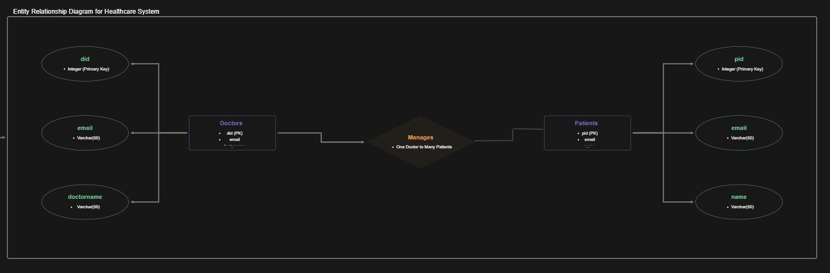

**5. Source Code**

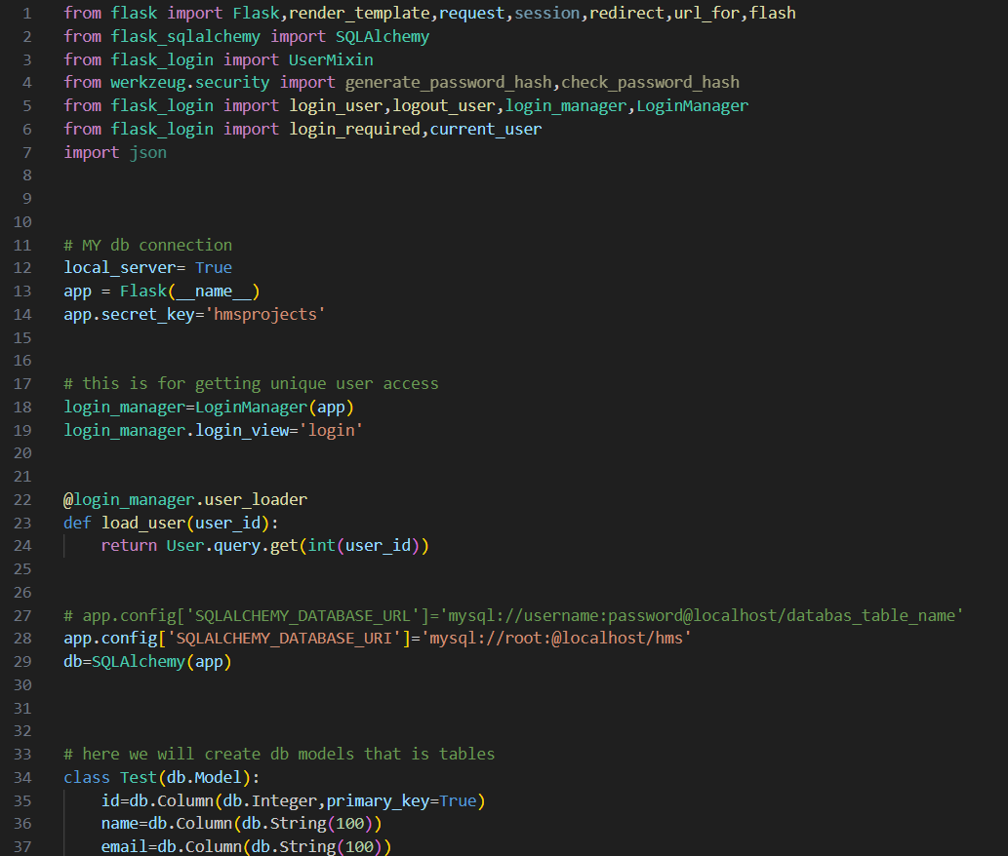

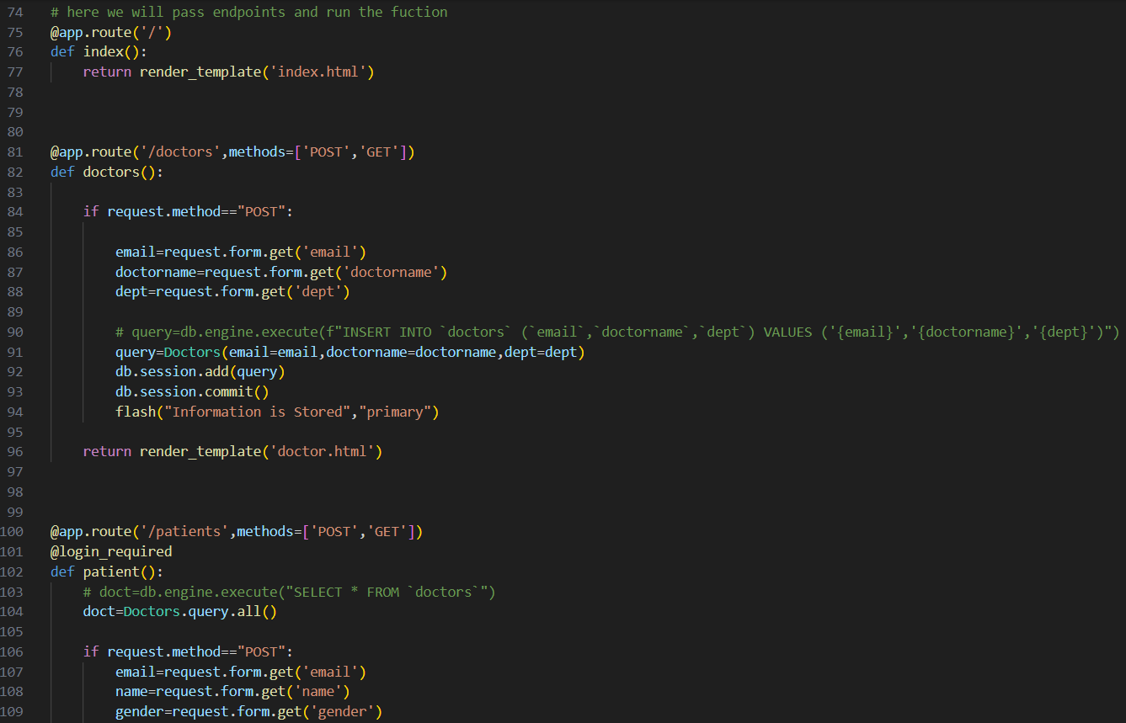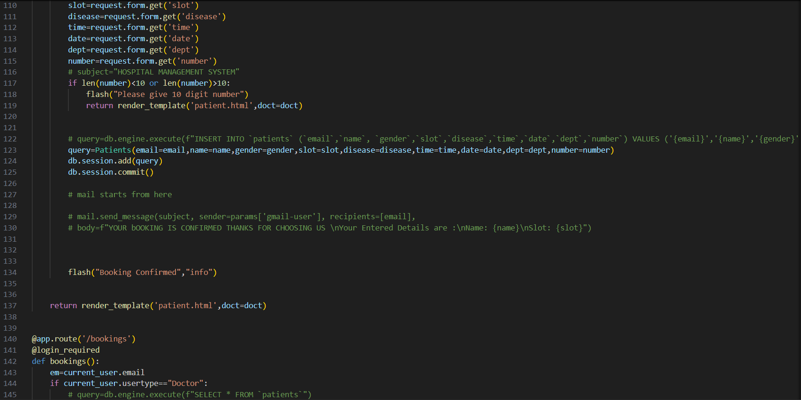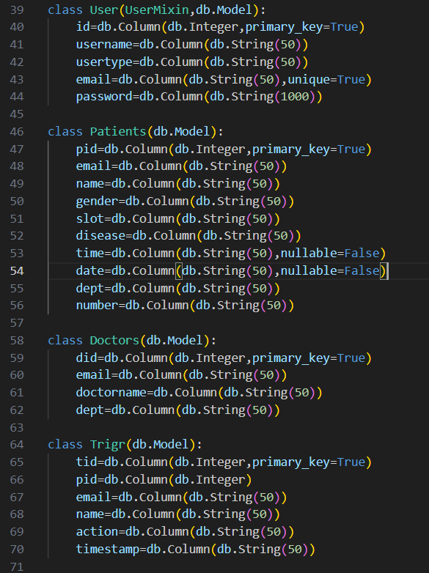

1. **Advantages and Disadvantages**

**Advantages :-**

1. Reduces manual paperwork and errors.

2. Ensures quick access to hospital data.

3. Scalable and easy to extend.

4. Provides data security through MySQL.

**Disadvantages:-**

1. Requires internet connection for web-based systems.

2. Limited to technical staff for system maintenance.

1. **Project Overview**

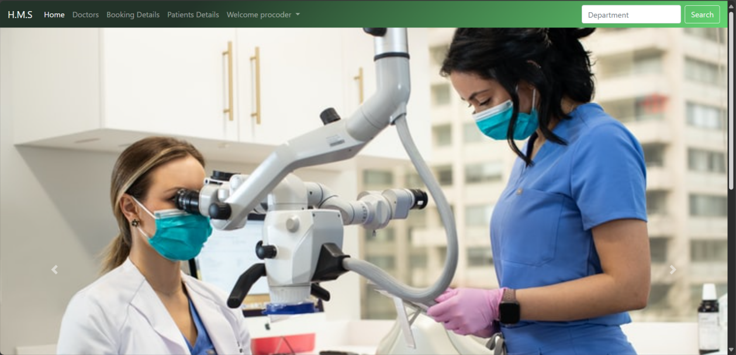

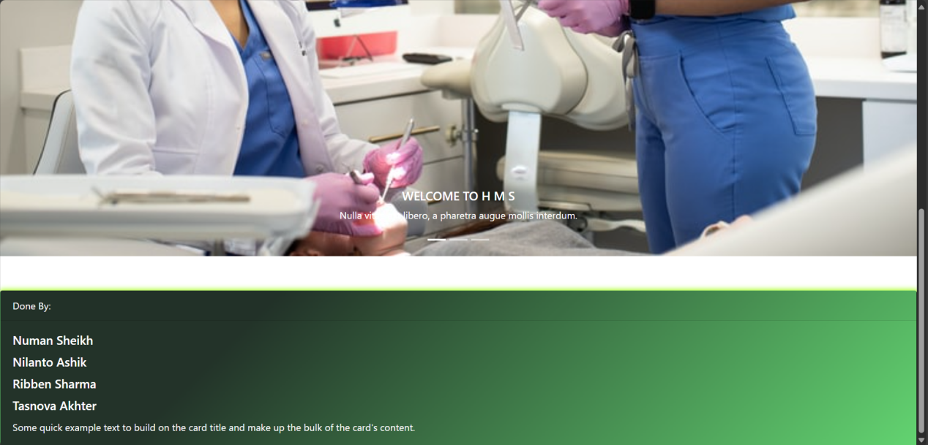

**8.Conclusion**

The Hospital Management System successfully automates hospital operations such as patient records, doctor information, and department management. It reduces paperwork and provides a user-friendly interface for administrators and hospital staff. Future improvements may include additional modules for billing and inventory management.

**9.Reference**

1. Flask Documentation: http//flask.palletesprojects.co
2. MySQL Documentation: <https://dev.mysql.com/doc/>
3. Python Official Site: https://www.python.org/